**DON BOSCO INSTITUTE OF TECHNOLOGY, KURLA**

**EXTC DEPARTMENT SE- SEM IV**

**MINI PROJECT FOR THE SUBJECT : PYTHON**

**ACADEMIC YEAR : 2021-2022**

|  |  |  |
| --- | --- | --- |
| **SERIAL NUMBER** | **GROUP MEMBERS** | **ROLL NUMBERS** |
| **1** | **ABHISHEK MANIK WAGHMARE** | **01** |
| **2** | **RAVEENA RUPESH PITALE** | **27** |

**TITLE : PHONE NUMBER TRACKER USING GUI**

**ACKNOWLEDGEMENT :**  Special thanks to Poonam Ma’am who conducted sessions on how to go about the project and also clearing all the doubts on time.

**PURPOSE OF PHONE NUMBER TRACKER :** The phone number tracker tracks an indiviual’s phone number and provides us with some of the important details of an user. This tracker can check the entered phone number and tell us six different specifications. These specifications include :

1. COUNTRY
2. SIM OPERATOR
3. TIME ZONE
4. DATE & TIME
5. LONGITUDE
6. LATITUDE

**CODE :**

import tkinter as Tk

from tkinter import *

import phonenumbers

from phonenumbers import carrier

from phonenumbers import geocoder

from phonenumbers import timezone

from timezonefinder import TimezoneFinder

from geopy.geocoders import Nominatim

from datetime import datetime

import pytz

root = Tk()

root.title("Phone Number Tracker")

root.geometry("365x584")

root.resizable(False,False)

root.configure(*bg*="#d896ff")

#background color code is #d896ff

#individual background color code is #d8b9ff

*def* track():

    enter_number=entry.get()

    number=phonenumbers.parse(enter_number)

    #country

    locate=geocoder.description_for_number(number,'en')

    country.config(*text*=locate)

    #sim operators like jio,airtel

    operator=carrier.name_for_number(number,'en')

    sim.config(*text*=operator)

    #timezone

    time=timezone.time_zones_for_number(number)

    zone.config(*text*=time)

    #longitude and latitude

    geolocator= Nominatim(*user_agent*="geoapiExercises")

    location=geolocator.geocode(locate)

    lng=location.longitude

    lat=location.latitude

    longitude.config(*text*=lng)

    latitude.config(*text*=lat)

    #time showing in phone

    obj=TimezoneFinder()

    result=obj.timezone_at(*lng*=location.longitude,*lat*=location.latitude)

    home=pytz.timezone(result)

    local_time=datetime.now(home)

    current_time=local_time.strftime("%I : %M %p")

    clock.config(*text*=current_time)

#logo

#logo = PhotoImage(file="logo image.png")

#Label(root,image=logo).place(x=240,y=70)

Heading=Label(root,*text*="TRACK NUMBER",*bg*="#d8b9ff",*font*=("arial",25,"bold"),*justify*="center")

Heading.place(*x*=43,*y*=110)

#entry

#Entry_back= PhotoImage(file="search png.png")

#Label(root,image=Entry_back).place(x=20,y=190)

entry=StringVar()

enter_number=Entry(root,*textvariable*=entry,*width*=19,*bd*=0,*background*="#d8b9ff",*font*=("arial",15),*justify*="center")

enter_number.place(*x*=75,*y*=200)

#button

#Search_image = PhotoImage(file="search.png")

search = Button(*text*="SEARCH",*width*=18,*bd*=1,*bg*="#d8b9ff",*font*=("arial",15),*justify*="center",*command*=track)

search.place(*x*=75,*y*=300)

#bottom box

#Box = PhotoImage(file="bottom png.png")

#Label(root,image=Box).place(x=2,y=355)

country = Label(root,*text*="COUNTRY:",*bg*="#d8b9ff",*fg*="black",*font*=("arial",10,"bold"))

country.place(*x*=50,*y*=400)

sim = Label(root,*text*="SIM:",*bg*="#d8b9ff",*fg*="black",*font*=("arial",10,"bold"))

sim.place(*x*=200,*y*=400)

zone = Label(root,*text*="TIME ZONE:",*bg*="#d8b9ff",*fg*="black",*font*=("arial",10,"bold"))

zone.place(*x*=50,*y*=450)

clock = Label(root,*text*="PHONE TIME:",*bg*="#d8b9ff",*fg*="black",*font*=("arial",10,"bold"))

clock.place(*x*=200,*y*=450)

longitude = Label(root,*text*="LONGITUDE:",*bg*="#d8b9ff",*fg*="black",*font*=("arial",10,"bold"))

longitude.place(*x*=50,*y*=500)

latitude = Label(root,*text*="LATITUDE:",*bg*="#d8b9ff",*fg*="black",*font*=("arial",10,"bold"))

latitude.place(*x*=200,*y*=500)

root.mainloop()

**OUTPUT :**

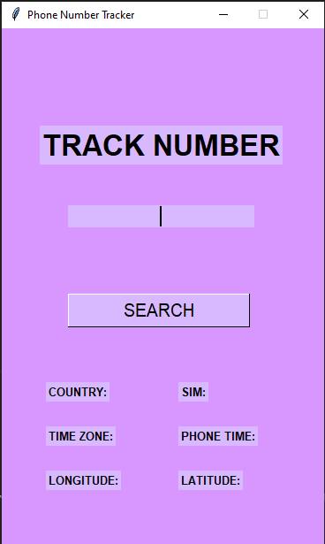 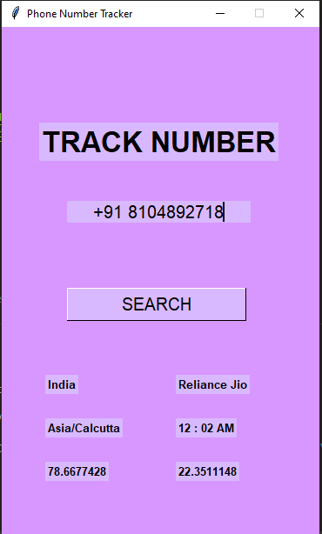

**CONCLUSION :**

1. We learnt what is GUI and how to use it
2. Installation of different libraries was necessary in order to collect the data and complete the execution.